UTEC-Peru Young Professional Network Summary of Activities

UTEC-Peru YPN was created at the Universidad de Ingeniería y Tecnología – UTEC in Lima, Peru in February, 2018. The YPN chapter started out with 20 members, all of them from an undergraduate program at UTEC, mainly from the environmental engineering department. Since its creation, the chapter has focused on organizing activities, both academic and recreational, for its members as well as research and sustainability activities.

Regarding the purely educational activities, UTEC-Peru YPN chapter organized several technical workshops such as a 2-day workshop on the basics of open-channel hydraulics and HEC-RAS, a QGIS workshop in order to discriminate fires in the Amazon and another QGIS workshop applied to Hydrology. Our organisation also arranged activities that were both recreational and educational. Some of these activities included trips to the beach to collect samples of sand to then analyze the microplastic content in them at the university’s laboratory and technical visits to the National Hydraulics Laboratory. The UTEC-Peru YPN chapter is also constantly involved in fundraising activities. This year’s activities included a merchandising sale near the holiday season, as well as a cupcakes sale at different dates during the present year. In addition, the peruvian chapter developed a sustainability panel called “Utec Sostenible” in collaboration with the Student Energy organisation at our university as part of promoting sustainability in our community. The invited panelists were two NGOs, Recicla,pe! and Ciudad Sostenible, who talked about the importance of recycling, circular economy and eco-labels. Furthermore, UTEC-Peru YPN chapter is keen on building a strong community, thus a picnic with an open invitation was organised as our closing activity of the academic year.

Finally, several members of our YPN are involved in research projects ranging from flooding caused by El Niño, understanding Amazonian river dynamics, studying microplastics in the Peruvian Pacific Coast and its relationship to solid waste management. As a result, two (2) members travelled to the National University of Cordoba in Argentina as undergraduate research assistants at the Department of Exact, Physical and Natural Sciences for 3 weeks. In addition, one of our members was awardee of the Kennedy-YPN Award in the IAHR World Congress held in Panamá, where our faculty advisor participated with an oral presentation about understanding how the Incan Hydraulic Structures worked and were designed. With the aim of involving young students in research, UTEC-YPN has created an interactive research chapter, where young students of any department at UTEC can create teams and propose a research topic on environmental issues. These proposals are being developed with a guidance from our advisor and other professors from our university with more knowledge in the specific topic. Our goal is to keep growing every year and to expand our network with international YPN chapters and to, possibly, host any international member that wishes to visit Peru. This will allow us to learn about other research initiatives worldwide and how we can apply those research initiatives in our home country.

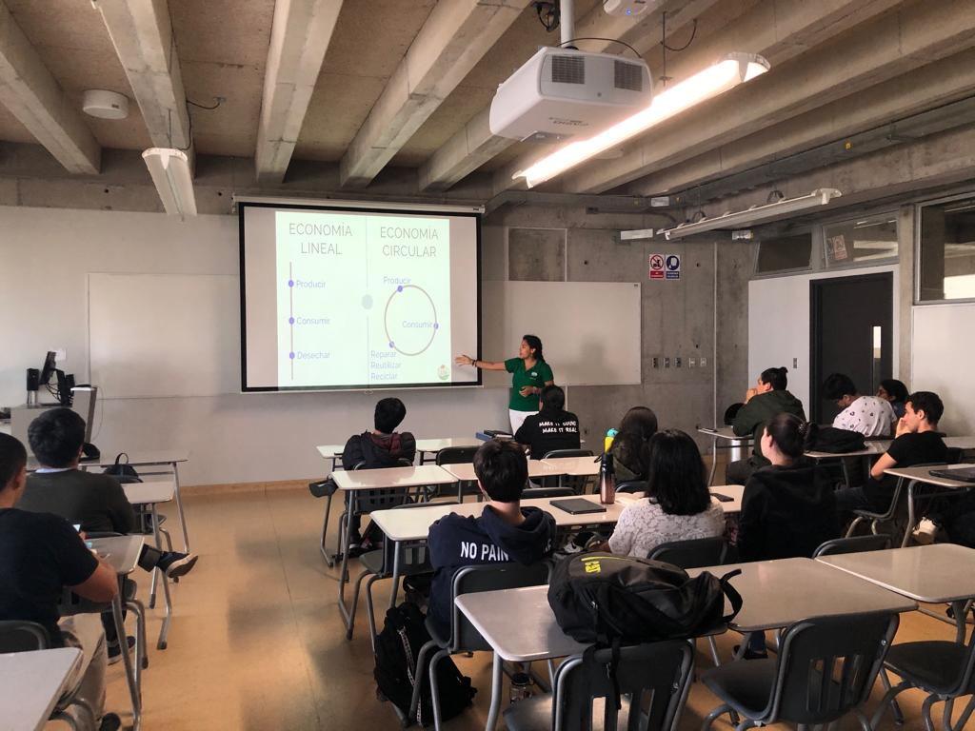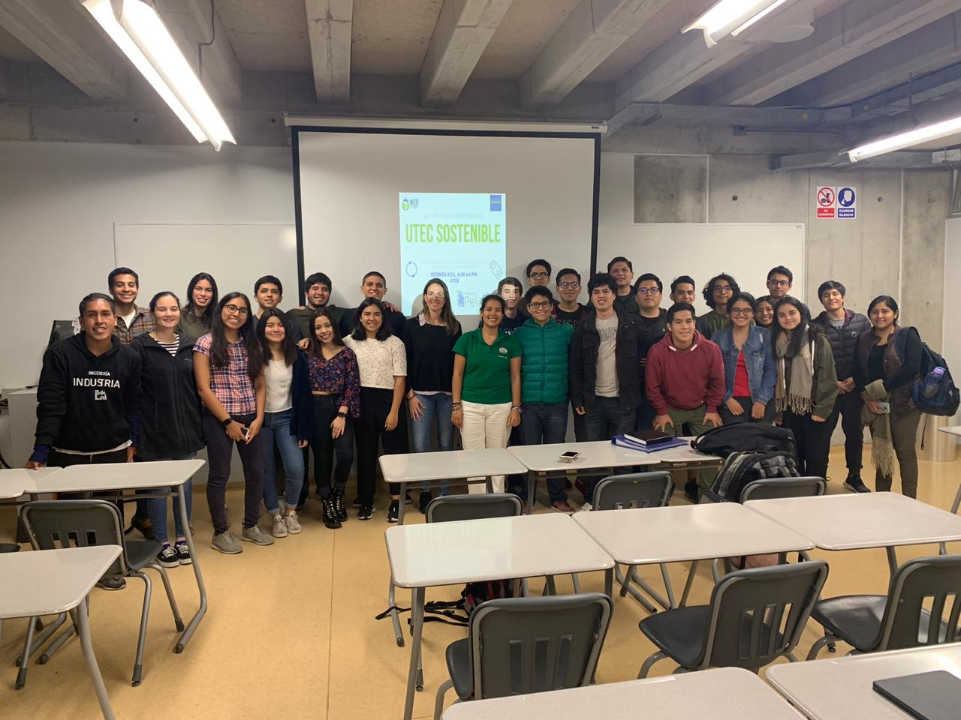
Picture 1. Sustainability panel “Utec Sostenible”

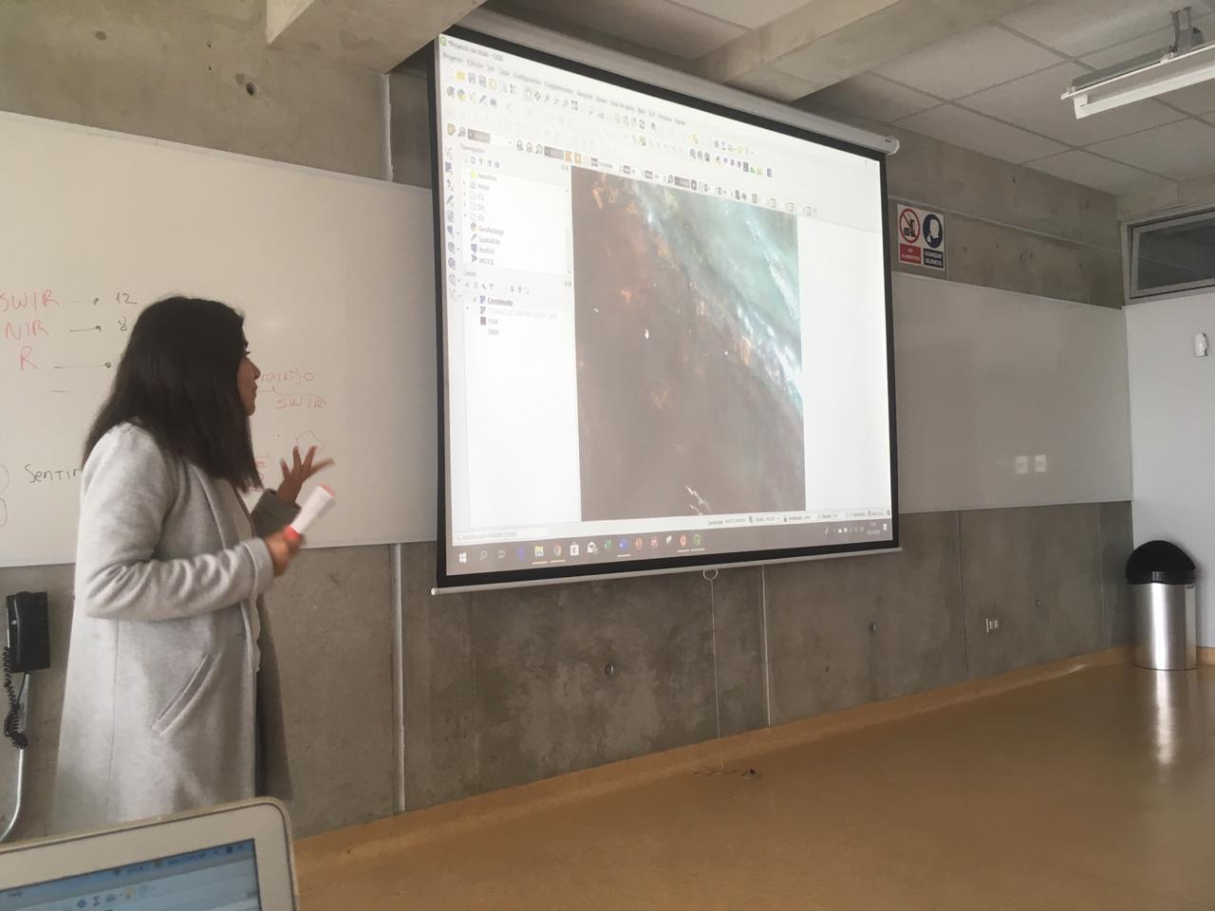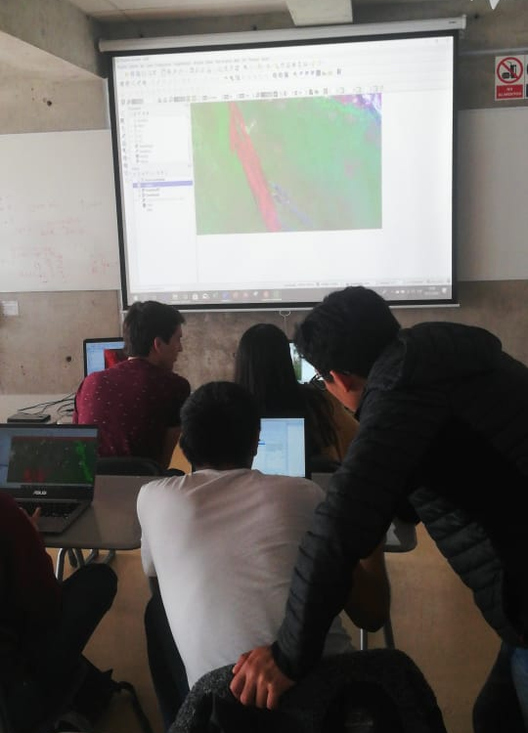
Picture 2. QGIS workshop

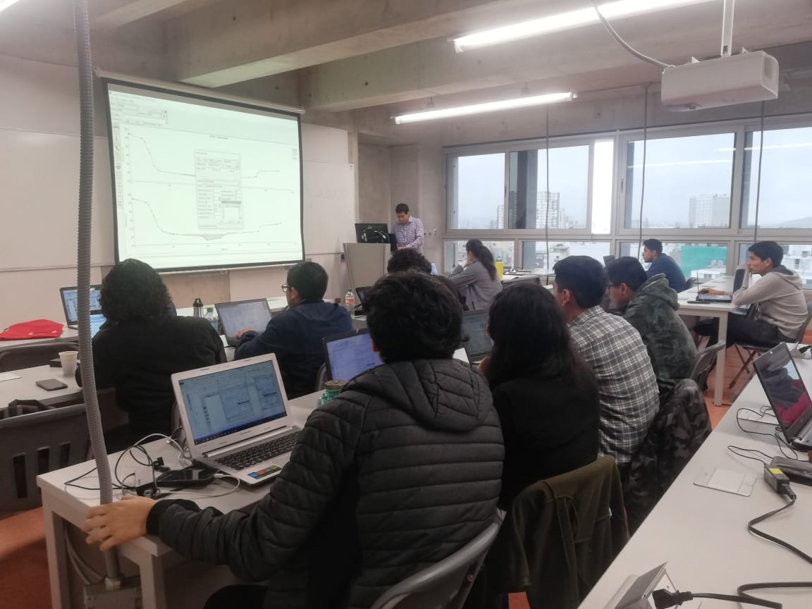
Picture 3. HEC-RAS workshop

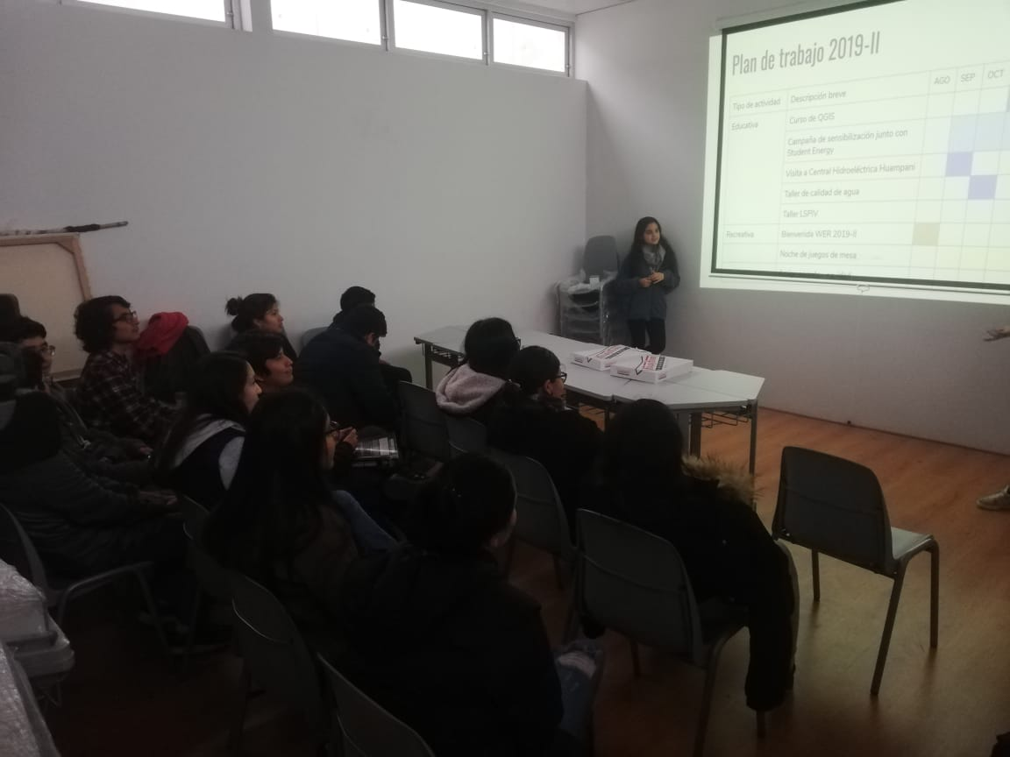
Picture 4. UTEC-YPN members meeting

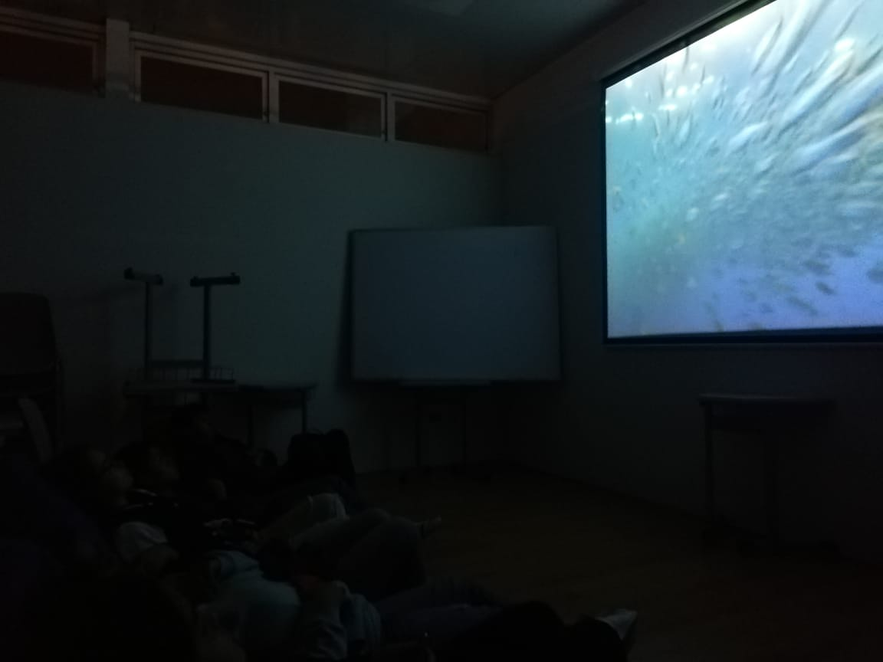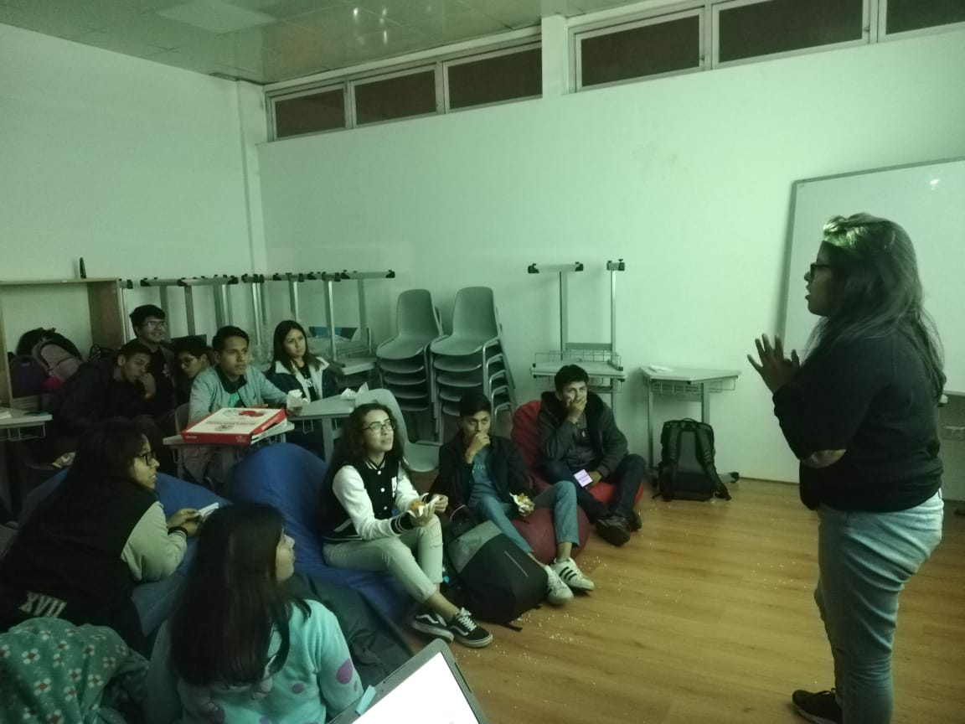
Picture 5. Movies night (Our planet)

